**User Guide**

Hardware Configuration

This software is designed to interface with up to three Keithley 2700 digital multimeters with two 7705 switching cards installed in each.

To install the switching cards:

1. Slide the switching card into the back of the multimeter, ensuring the connector on the card mates with the connector inside the multimeter.
2. Line up the screws on the switching units with the holes on the Keithley mount and tighten.
3. Repeat for the second switching card.

If more than one Keithley is being used, they must be chained together via the IEEE-488 ports on the rear of the device before connection to the PC. The connection between the Keithley(s) and the PC requires a National instruments IEEE-488 to USB connection and the National Instruments drivers to be installed.

The Keithley

Any legal GPIB address can be used, but it is recommended that they be changed from the default (16) on all multimeters to avoid naming conflicts in the event of a default to factory settings.

The GPIB address can be changed via the front panel by:

1. On the front panel of the Keithley press the “Shift” button once to access the second level of front panel controls. The multimeter display should show “SHIFT” when the shift mode is active.
2. Press the “Exit” button (with shift this is the “GPIB” button)
3. Press the up arrow button to access the GPIB address menu option
4. Press the right arrow button to access the digits of the GPIB address. These can be changed with the up and down arrow buttons
5. Press “Enter” on the desired address to set it

If using more than one multimeter, the GPIB addresses **must** be distinct.

Finally the multimeter(s) must be connected to the switching units via the 50 pin GPIB connectors on the rear of each device. Looking at the devices from the rear, the corresponding output and input connections are shown below.

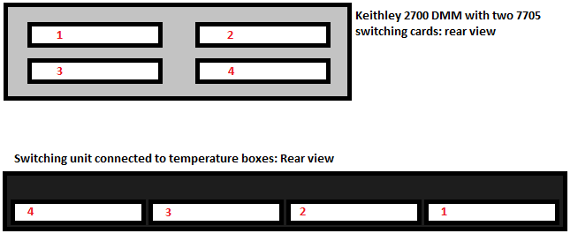

The Biologic potentiostats must be set up and calibrated as described in their respective manuals, available through EC-Lab. The output cable of the potentiostat has six banana-plugs labelled:

* REF 1
* REF 2
* REF 3
* GROUND
* CE/CA1
* WE/CA2

To connect the potentiostat to the scanning unit the following connections must be made:

1. Connect REF 1 to the green wire: the positive voltage wire
2. Plug REF 3 into REF 2 and connect to the black wire: the negative voltage wire
3. Connect GROUND to the bare metal wire: the common ground
4. Connect CE/CA1 to the white wire: the negative current wire
5. Connect WE/CA2 to the red wire: the positive current wire
6. Ensure the connections made are good

The potentiostat must also be connected to the Keithley multimeter for the triggering capability. The trigger port on the Biologic potentiostat is a DB9 connector located on the faceplate with female pins. The trigger port on the Keithley multimeter is a DIN8 connector located on the backplate with female pins. The schematics for these connectors are shown below with a description for the corresponding pins.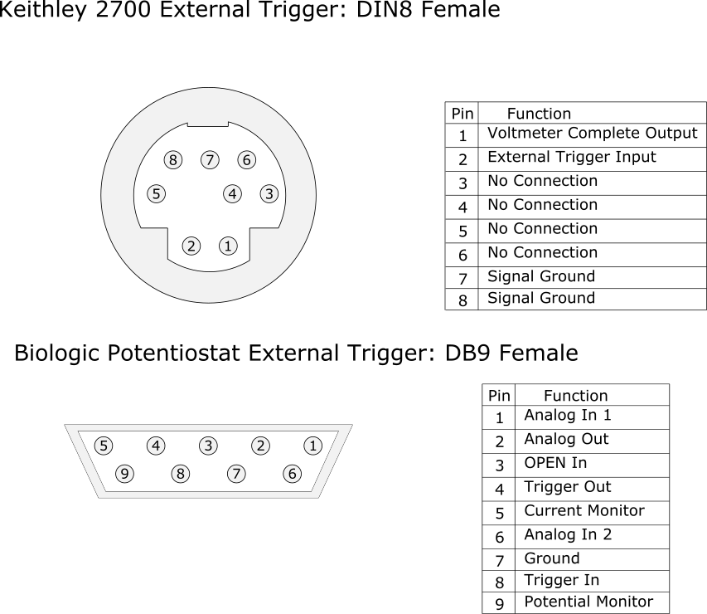

To connect these trigger ports together, a male DIN8 to male DB9 cable is needed and **must** be wired as follows:

* DIN8 pin 1 to DB9 pin 8
* DIN8 pin 2 to DB9 pin 4
* DIN8 pin 7 to DB9 pin 7
* DIN8 pin 8 to DB9 pin 7

The schematic for the cable ends is shown below, with the pin connections specified. Note the mirror image of the pins from the trigger ports shown above.

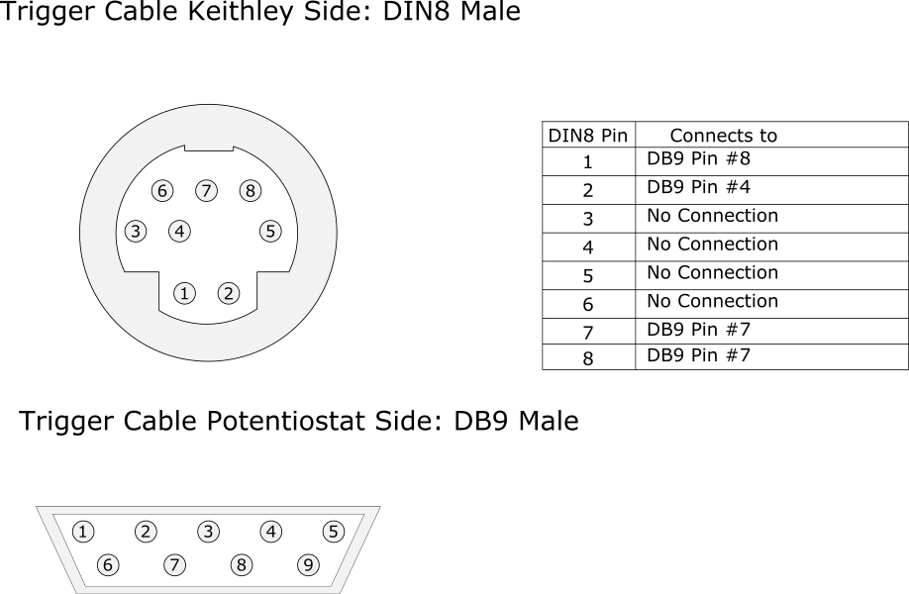

EC-Lab Settings

For this program to work with EC-Lab, the scanning routine **must** be in the following format:

1. Wait (1.5 seconds)
2. Trigger Out (Falling edge, 0.0004 seconds)
3. Open Circuit Voltage (10 seconds)
4. 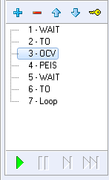 At least one scanning Routine (PEIS, GEIS, etc.)
5. Wait (5 seconds)
6. Trigger Out (Falling edge, 0.0004 seconds)
7. Loop (Go to step 3 until done)

The “Wait” routines ensure that the Keithley has adequate time to receive and perform the commands sent by Visual Basic and to protect against premature scanning of an unopened channel.

An external trigger is sent from the connected potentiostat to the Keithley using the “TO (Trigger Out)” routine. This trigger is configured to be a 400 microsecond falling edge, which meets the specification for an input trigger given in the Keithley 2700 manual.

The “OCV” technique is similar to the “WAIT” routine but allows the potentiostat to recalibrate when a new cell is connected. This is necessary for getting accurate measurements of a cell.

The scanning routine will most commonly be the Potentio Electrochemical Impedance Spectroscopy (PEIS) scan with parameters specified by the user via a settings file or through the EC-Lab software. However, any other scanning procedure could be used if multiple channels with switching are required. It is also possible to run multiple scans on the same channel by inserting more scanning routines between “OCV” and the following “WAIT”.

When performing scans over multiple channels, the “Loop” routine is used to move the scan back to step 3 a specified number of times until the scan is done. For a scan over N channels, the loop should be set to return N-1 times.

An example routine is shown below, with the parameters visible. The external trigger commands are both identical, so only one is shown to save space.

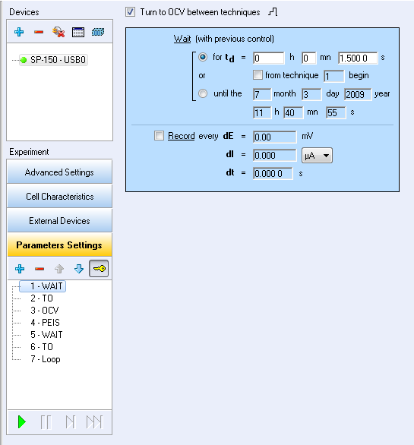

The initial “WAIT” command is set to be 1.5 seconds. This ensures that there is adequate time for the switching software to receive the initial start trigger after the user clicks the “Start Scan” button.

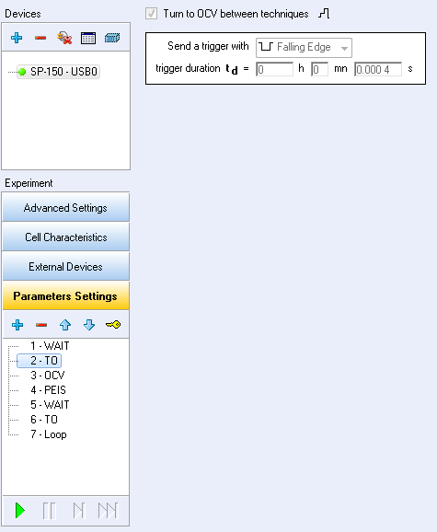

According to the Keithley 2700 manual, a valid trigger must be a rectangular pulse with a pulsewidth of **at least** 20 microseconds. Because the trigger line is at logical high (5V) by default, the EC-Lab trigger pulse **must** be a falling edge. The pulsewidth is specified as 0.0004 seconds, or 400 microseconds.

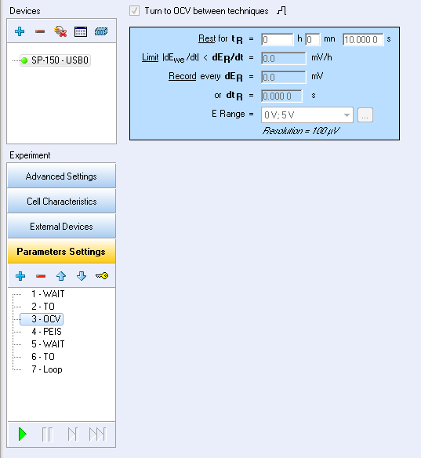

The “OCV” command behaves like the “WAIT” command but allows the potentiostat to read the new cell voltage before any perturbation. This ensures the correct ‘baseline’ potential is used by the software to calculate the impedance spectrum.

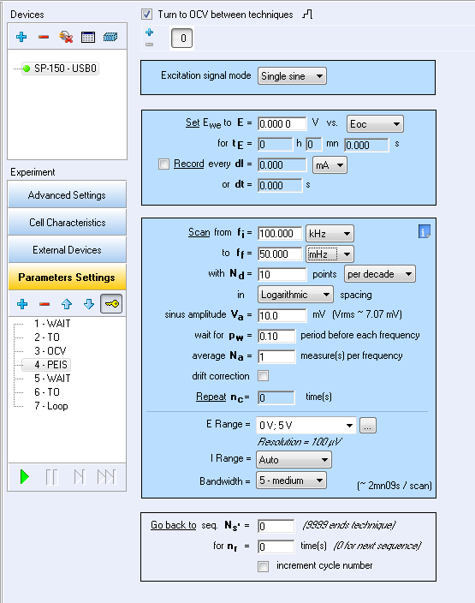

The “PEIS” technique is the actual scan performed on the cell. For the majority of users, the only parameters that need to be changed are “Scan from **fi**” and “Scan to **ff**”; the initial high frequency and the final low frequency. The routine file attached to this software will have the exact parameters shown above, and outside of the initial and final frequencies, should not be modified unless the user requires it.

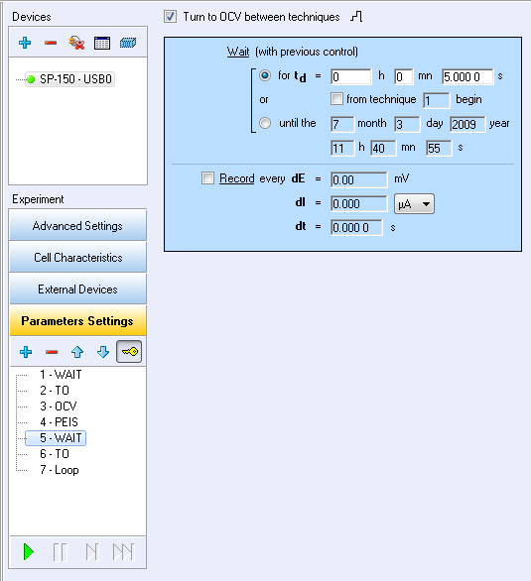

The second “WAIT” routine ensures that the final data point on the EIS routine is plotted before the channel is changed. It should be about 5 seconds for safety. The second “TO” trigger command is identical to the first, so it is omitted.

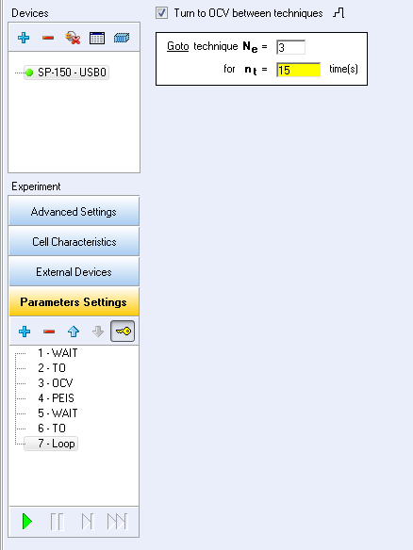

The “Loop” command sends the routine back to step 3, the “OCV” command. For a scan over 16 channels, the routine is sent back 15 times.

Starting the Software

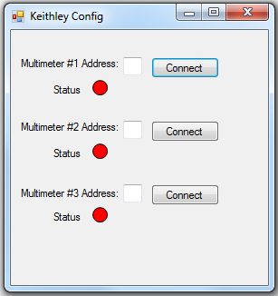Upon starting the software, the first form that loads is the multimeter configuration form, shown below.

Entering the GPIB address of a multimeter in the textbox labelled “Multimeter #X Address:” and clicking “Connect” instantiates a GPIB communication between the software and the multimeter. After the initial communication is completed, the form shown below loads for each connected multimeter. This is the front panel, from which each channel status is visible and scans can be run. From this form, the user can open the form to start a scan, or the output file processing form.

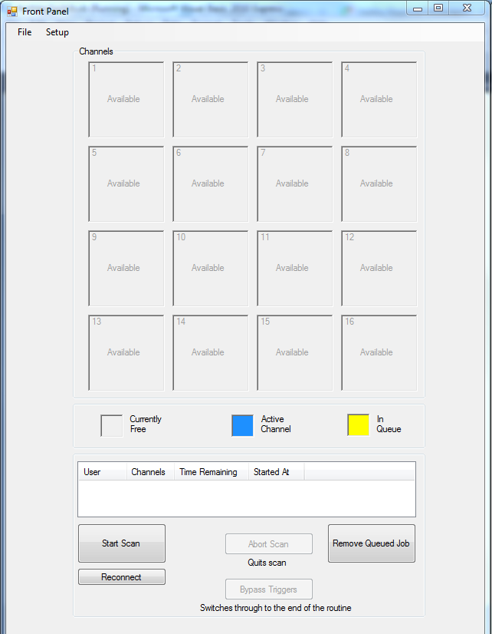

Configuring a Scan

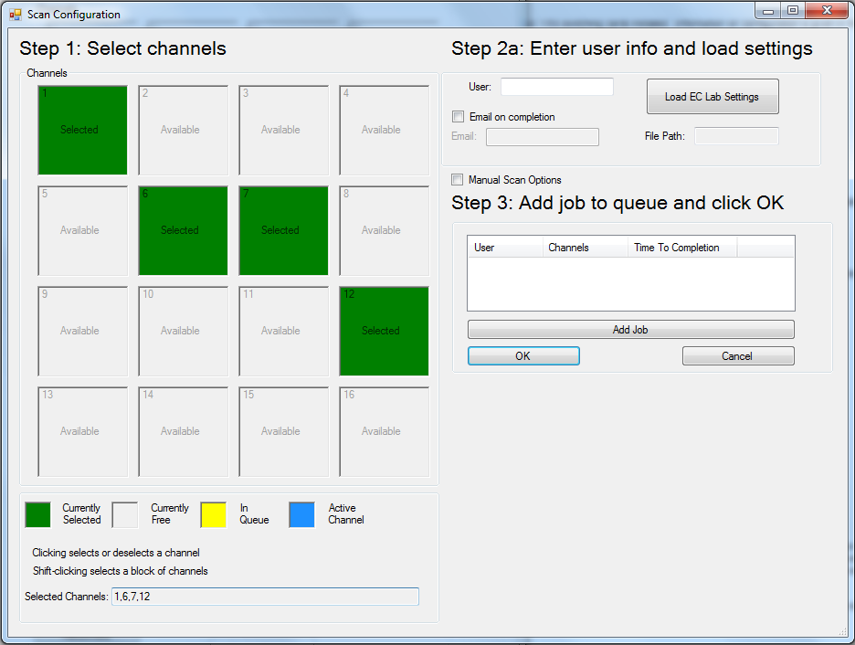The panel on the left-hand side of the form shows selected (green), free (grey) and reserved (yellow) channels. If a scan is running, the currently active channel has a blue background and a timer showing how long the channel has been active. There will only be one active channel at a time, and it will revert to being a free channel upon scan completion.

A scan can be added to the queue while the software is idle, or while a scan is running. To add a scan to the queue:

1. Click the channels required for the scan to select them (green). They will automatically be added to the “Selected Channels” textbox below the panel.
   1. Clicking the channels again deselects them (grey) and removes them from the “Selected Channels” textbox.
   2. Shift-clicking selects a block of free channels from channel 1 onwards and adds them to the textbox.
2. Enter a username. A username must be supplied to add the scan to the queue which ensures that the user running the scan can be notified in case of scan failure. This also makes inspection of the software log file more convenient.
3. Load the EC-Lab settings file
   1. If no file is loaded, a default scan settings file will be loaded.
   2. Alternatively, by clicking the “Manual Scan Options” checkbox, scan options can be added manually.
4. Click “Add Job” to add the job to the queue and “OK” to close the form.

Starting a Scan

On the front panel, the list box with headings “User”, “Channels”, “Time Remaining” and “Started At” shows the currently loaded scans. Clicking the button “Start Scan” will prime the software for the initial trigger pulse from the potentiostat. At this point, the EC-Lab routine should be run.

Processing Output Files

EC-Lab produces output files in two formats:

* Binary format, where the data is written to a file in machine readable bytecode.
* Text file format, where the data is written to a file in human readable ASCII text format.

**System Recovery**

Exception Handling

In the event of a power interruption to one or more multimeters, the software will notify the user of an error as it arises. The software will then wait for user input to either:

* Attempt a reconnection to the multimeter and then to retry the scan
* Abort the scan and remove it from the job queue
* Abort the scan and reset the job queue

Catastrophic Failure

Although the software handles many exceptions that may occur during usual operation, it cannot protect against catastrophic failures such as power outages or operating system crashes. To aid users in recovery from a crash, log files are saved in “C:\EISLog” and provide details of the most recently run scan. There are three log files, each corresponding to one of the active multimeters.

The software writes the following events to the log file:

* A scan is started
* When the multimeter switches to a channel, before the EIS scan
* When the EIS scan on a channel has finished and the system is preparing to switch the channel
* A clean finish of the scan
* When the user aborts the scan
* If the scan crashes for any reason
* When the user attempts to retry a scan following a crash
* When the user aborts and removes a scan from the queue following a crash
* When the user aborts and resets a scan in the queue following a crash

Following a major failure of the scanning software, the user can inspect the log file and determine which channels failed to complete. An example log for a successful scan over channels 4 and 10 is shown below, followed by a log where the multimeter lost power and the user aborted the scan.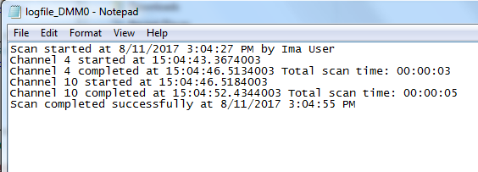

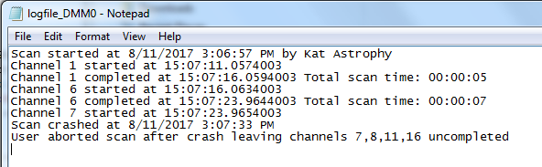

**Troubleshooting and Debugging**

Although every attempt has been made to make the software stable, some issues may arise as a result of synchronization errors between the potentiostat and multimeter, equipment failure, or unhandled bugs in the code.

Following are some issues which may arise and their solutions:

* My scan is stuck on a channel!
  + Most likely caused by too few triggers received by the Keithley. Clicking the “bypass triggers” button will cause the program to switch through all remaining channels and exit cleanly.
* A Keithley is not receiving commands from Visual Basic!
  + This is most likely caused by a crash in the GPIB driver used by Visual Basic. Close the window corresponding to the troubled Keithley, make sure all connections are secure and attempt to reconnect.
  + Failing this, it may be necessary to restart the program. Please ensure all other scans are complete and/or other users are notified of the reboot.
  + Failing this, the issue may be hardware related.
* I added/started a scan that I didn’t want!
  + If the scan is added to the job queue but not started, click “Remove Job from Queue” to remove the first job
  + If the scan is already started, click “Abort Scan” to quit the scan and remove it from the queue.

**Quick Start Guide: Configuration**

This guide assumes that the user has a computer with EC-Lab installed and National Instruments GPIB drivers as well as the required temperature box and switching unit setup.

It is also assumed that the user is in possession of up to three Keithley 2700 digital multimeters with two 7705 switching cards installed per unit and the required cables to link multiple Keithleys to the computer and the switching cards to the switching units.

Finally, the user is also assumed to have an equal number of Biologic potentiostat units with USB connections to the PC and DB9 to MicroDIN cables for sending trigger pulses to the Keithleys.

1. Connect the multimeters to each other via the IEEE-488 ports (if required) and then connect the device(s) to the computer.
2. On the front panel of the first Keithley, press “SHIFT🡪EXIT🡪Up arrow” to access the GPIB address configuration menu.
3. Enter a legal GPIB address (00-30) and press “ENTER” on the front panel to set the new GPIB address. It is suggested to not use the default address of 16 to prevent naming conflicts.
4. Connect all four outputs (two per switching card) on the back of the multimeter to the inputs on the switching units. To ensure the channel ordering is correct: while facing the **back** of the multimeter **and** switching cards connect the top-left multimeter output to the rightmost switching unit input, the top-right multimeter output to the next switching unit input (moving left), the bottom-left output to the next switching unit input and finally the bottom-right output to the leftmost switching unit input. Ensure the numbering of the multimeters matches the switching units.
5. Repeat steps 2-6 until all multimeters are configured. The addresses **must** be different for each multimeter.
6. Connect the Biologic potentiostat unit to the PC.
7. Connect the DB9 output of the potentiostat to the MicroDIN input on the Keithley.
8. Connect the scanning connection of the potentiostat to the scanning connection of the switching unit. Ensure the numbering of the potentiostats matches the switching units.
9. Repeat steps 6-9 until all potentiostats are configured.
10. Start the EC-Lab software and ensure that the Biologic potentiostat(s) are detected.
11. Load an EC-Lab scanning routine by
    1. Loading a scan settings file meeting the format specified in this manual.
    2. Manually create the scan ensuring it follows the format specified in the manual.
12. Run the Visual Basic software.

Please refer to the next quick start guide (scanning) for information on starting and running a scan.

**Quick Start Guide: Scanning**

This guide assumes that the scanning software is running and is connected to at least one Keithley 2700 digital multimeter with two 7705 switching cards installed. Information on configuration is given in the previous section.

It is also assumed that the EC-Lab scanning routine is in the format described in the next sections and a functioning potentiostat is connected to the PC.

Finally, it is assumed that the user has loaded their cells into the temperature box and is aware of the channels they are using.

*The notation* (**Software**) *means the following steps are for that particular software, until otherwise mentioned.*

1. (**Visual Basic**) Enter the GPIB address(s) of the multimeter(s) and click “connect” to open the scan front panel(s)
2. Click “File 🡪 Start scan” to open the scan configuration form.
3. Select, by clicking, the channels required for the job. They will be added to the list below the channel display.
4. Enter your name in the “User” textbox.
5. *Optional*: For an email alert upon job completion, check the “email on completion” checkbox and enter your email address in the “Email” textbox.
6. *Optiona*l: Select the destination for your log file by clicking the “Select Scan Log Folder” button
7. Click the “Add Job to Queue” button to add the currently configured scan to the job list.
8. Click “OK” to close the scan configuration form.
9. Click “Start scan” to prime the software for the initial trigger from the EC-Lab routine.
10. (**EC-Lab**) Click the “run” button (green arrow) and choose the folder in which to save the output.
11. The potentiostat will send the initial trigger to the Keithley and the first channel will be engaged. EC-Lab will then perform a scan on the active channel and send an output trigger upon completion, enabling the next channel until the scan is completed.